**Scope**

Applicable to maintenance and repair work on installations and machines

**What and how?**

1. **Interruption of the entire power supply to the installation:**

Make sure that the installation to be worked on is fully switched off. Switch it to the off position.

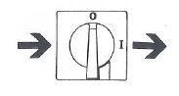

Consider all forms of energy (electricity, steam, hydraulic liquid under pressure, compressed air, etc.). Interruption is best made visible.

1. **Precautions against switching back on:**

Make sure that the installation cannot be switched on again without your permission.



Four possible ways:

* + - 1. Message at switch or closing device with the order to not switch back on



* + - 1. Removal of safety fusing/ locking of safety fusing



* + - 1. 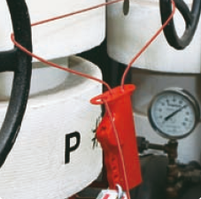Fitting a padlock on the switching device
      2. Disconnection of pressure pipes

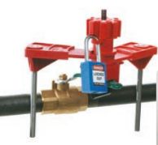

1. **Neutralisation of energy:**

Any residual energy that can still be present in the installation must be neutralised.



This particularly concerns energy that can have accumulated in:

* Electrical capacitors
* Still moving parts (inertia)
* Compressed gases
* Masses hoisted at height (to be lowered or blocked, mechanically or with structural member)

1. **Control**

The control is to check that there are no defects and no human errors have been made (such as operating a wrong switch). Carry out the control with all precautions one would take if dangerous energy was still present in the installation.

**Kuwait Petroleum North West Europe**

DOCUMENT TITLE: Lock out tag out of machines

DOCUMENT NUMBER: KPNWE.WI.11.HSCO.019

REVIEW NUMBER: 0

EFFECTIVE DATE: 01 Dec 2017

NEXT REVIEW DATE: 01 Dec 2020

..

**CONFIDENTIALITY:**

The information contained in this document is confidential to Kuwait Petroleum International Ltd. Copyright © Kuwait Petroleum International Ltd. Copying of this document in any format is not permitted without written permission from the management of Kuwait Petroleum International Ltd.

**This document is reviewed and approved according to the released online Document Approval Flow**

|  |  |  |
| --- | --- | --- |
| Prepared by: | Operational Assistant | An Cornelis |
| Reviewed by: | Operational Assistant | An Cornelis |
| Approved by: | HSSE Manager | Gerardus Johannes Marinus Timmers |

# *Access rights: Generally Accessible

**Reviews Summary**

|  |  |  |  |
| --- | --- | --- | --- |
| **Review date** | **Review reference** | **Review details** | **Review version** |
| **2017-12-01** |  |  | **0** |