- INTRODUCTION TO CONFINED SPACES
Confined spaces are hazardous working environments as they they are often damp, dark and poorly ventilated. The risks encountered here can also be encountered elsewhere, but in confined spaces is much harder to do something about it. It is therefore important to always be aware of the risks and to closely observe safety measures.

- EXPLANATION & RISKS
- Confined spaces are spaces - also above ground:  - that are not readily accessible  - that are not easy to exit quickly  - with poor ventilation  - with no or poor lighting  - with little room to move  - where a hazardous atmosphere is present  - which are not intended for a long stay  - with pipes and cables in unexpected places  - that are small, damp and inconvenient | Examples:  tank, measuring well  excavated wells, deep trenches  tanks  tanks  crawl space, measuring well  tanks, oil separator  see other examples  passages, elevator shaft  sewers, drains
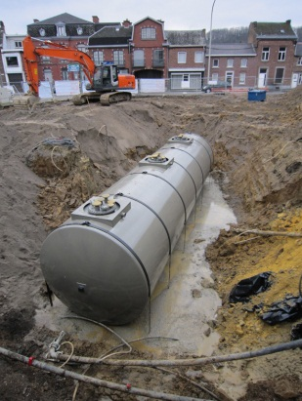
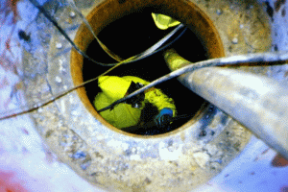
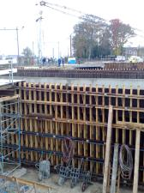

- There are many risks involved with confined spaces: (pictograms and additions)
- fire and explosion caused by vapours/gases in the room itself or that may be created due to the nature of the work (fire and sparks)
- suffocation due to oxygen deficiency
- poisoning caused by hazardous substances from the work, piping, welding, ...
- electrocution due to sweating (wet skin) because of poor ventilation or conductive materials in the space
- pinching due to lack of space to move, especially if there are moving parts
- falling and slipping through products present, moisture, moss formation

- SAFETY REQUIREMENTS
ALWAYS REQUIRED !!!
CHECK
- Standard PERSONAL PROTECTIVE EQUIPMENT
- protective clothing
- safety glasses
- safety gloves
- safety shoes or boots
- safety helmet
- fall protection/rescue equipment if necessary
- Manhole, outside or safety GUARD
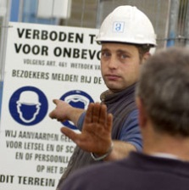
ALWAYS keep 1 person outside as a safety guard - tasks:
    - communication with persons in the confined space;
    - monitoring of ventilation device;
    - call in emergency services in the event of an accident
and provide assistance to the person in the confined space.

- SIGNAGE - DEMARCATE THE WORKPLACE
e.g. safety ribbon, fencing or strong grids (concrete grid) on the openings
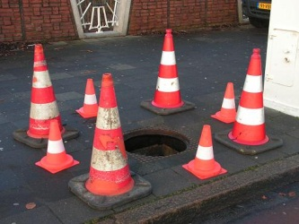
- open wells
- horizontal manholes
- open ventilation holes
REQUIRED WHEN APPLICABLE
CHECK
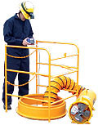
- VENTILATION and AERATION for
- removal of dust from the space itself ventilation in general
- dust caused by work local removal
- or both if both are available

REQUIRED WHEN APPLICABLE
CHECK
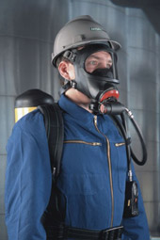
- INDEPENDENT RESPIRATORY PROTECTION.
- with concentration of hazardous gases > limiting value
- as oxygen concentration < 19%
- MEASURING OF OXYGEN, TOXIC AND HAZARDOUS STOFFFEN
e.g. with welding, cutting, painting, varnishing and solvents
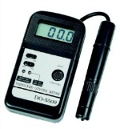
- before entering if
    - oxygen - minimum 19%
    - vapour or gas concentrate - < 10% of the LEL
    - hazardous substances - below the limit value
- continuously if these risks remain
See also TSR Measurements
- EVACUATE OF PEOPLE FROM CONFINED SPACES
Objective: it must always be possible to remove the person from the confined space without any difficulty and without the safety guard having to enter the confined space
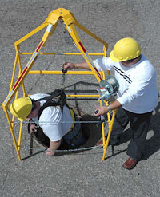
Options: - lifeline
- fall harness
- with tripod hoist (with motor)
- FLAMMABLE SUBSTANCES in a confined space
e.g. with welding and cutting
- remove or cover all combustibles
- put spark arrestors in place
- EXTINGUISHING MEDIA
- always required with flammable materials in confined spaces
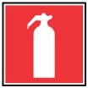
- always kept outside and near the entrance to the confined space
- adequate fire extinguishing equipment must always be available

REQUIRED WHEN APPLICABLE
CHECK
- LIGHTING in the confined space
- always required when the exit is not visible
- always needed when slipping or falling must be avoided
- explosion proof lighting in explosion risk areas
- ELECTRIC APPLIANCES
- in explosive atmosphere explosion-proof appliances and lighting
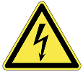
- no transformers in the confined space
- make use of devices on secure voltage
- electrical installations in the confined space must be turned off
TIP: special attention is required for the isolation - and especially against damage - of cables, devices and grounding of the conductive walls of the enclosure
- HEARING PROTECTION
- with noisy work and/or
- when the nature of the confined space requires it

Kuwait Petroleum North West Europe

DOCUMENT TITLE: TSR - Confined spaces

DOCUMENT NUMBER: KPNWE.WI.11.HSCO.063

REVIEW NUMBER: 0

EFFECTIVE DATE: 01 Dec 2017

NEXT REVIEW DATE: 01 Dec 2020
..

CONFIDENTIALITY:
The information contained in this document is confidential to Kuwait Petroleum International Ltd. Copyright © Kuwait Petroleum International Ltd. Copying of this document in any format is not permitted without written permission from the management of Kuwait Petroleum International Ltd.

This document is reviewed and approved according to the released online Document Approval Flow

Prepared by: | Operational Assistant | An Cornelis
Reviewed by: | Operational Assistant | An Cornelis
Approved by: | HSSE Manager | Gerardus Johannes Marinus Timmers

*Access rights: Generally Accessible

Reviews Summary

Review date | Review reference | Review details | Review version
2017-12-01 |  |  | 0

