- INTRODUCTION TO ELECTRICITY
You cannot see electricity, so you often do not know whether something is live or not. An electric shock or current through the human body can cause serious damage (cramps, cardiac fibrillation, burns ...). It is therefore important to always take safety precautions when working with electricity.

- EXPLANATION & RISKS
- Definitions:  - Working (installation, repairs, troubleshooting, inspection) on or near electrical installations or equipment where there is a risk of contact or a short circuit  - High voltage =  - > 1000 V alternating current  - > 1500 V direct current  - Low voltage =  - < 1000 V alternating current  - < 1500 V direct current  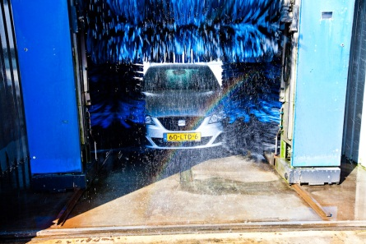 | Examples:  maintenance work on forecourt (forecourt, cameras, lights, ...)  work in the shop (fridge, alarm systems, cameras, ...)  HS cabs at depots  installations (air conditioning, elevator, ...) in offices and stations  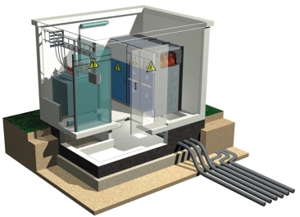  electrical parts in car washes  {0><}98{>HS<0}
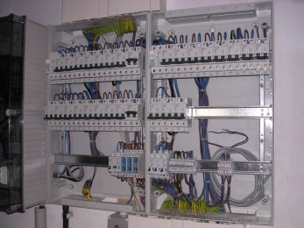

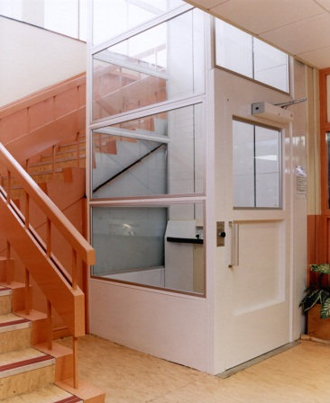
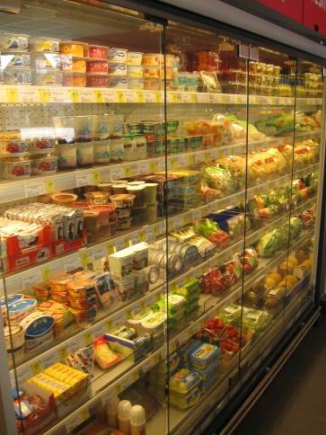
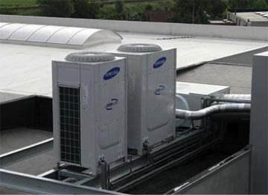

- The following risks exist (description of the risks + pictograms):
- electrocution of persons
! with high voltage contact is not even necessary !
- buns caused by electric arcs
- fire and explosion
- faulty machines

- SAFETY REQUIREMENTS
ALWAYS REQUIRED !!!
CHECK
- PERSONAL PROTECTIVE EQUIPMENT
- protective clothing
- safety glasses
- safety shoes
- safety shoes or boots
- + when working with power
    - isolating tools
    - isolating gloves
    - isolating carpet
- + with risk of electric arcs
    - safety helmet
    - mask
- MAIN RULE = SWITCH ELECTRICITY OFF WHILE WORKING
TIP: 5 vital rules
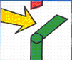
- SWITCH OFF
    - Make sure that the unit that you are working is switched off.
Ensure that is visible that the unit is switched off.

- LOCK
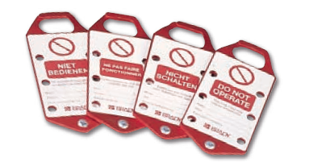
    - Prevent the unit from being switched back on
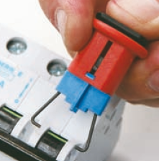
      - at the switch or disconnection point
by prohibiting it from being switched on
OR
      - remove the fuse or lock the fuse

ALWAYS REQUIRED !!!
CHECK
- MEASURE
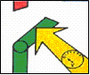
    - Do a voltage test on each conductor that forms part
of the switched off unit:
      - the result must always be 0.
      - the measuring device must be designed for this purpose
      - test the operation of the device in advance

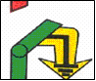
- GROUNDING & SHORT CIRCUIT
    - Ground and lock each conductor
together close to the switched off
unit.

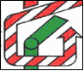
- DEMARCATE
    - Apply isolating shielding plates, sheets or
other materials to prevent contact with
live or open parts of units
that are not switched off.
- EXCEPTION = WORKING WHILE LIVE
ATTENTION: ONLY PERMITTED IF the following conditions are met
- urgent need for this must be demonstrated
AND
- express written consent of KPNWE
AND
- the unit must be suitable for this
AND
- a 2nd person (safety guard) must be present - 4-eye principle
AND
- additional precautions
    - isolating protective equipment (see 1.e above)
    - protection equipment against electric arc (see 1.f above)

ALWAYS REQUIRED !!!
CHECK
- OTHER PRECAUTIONS
- always demarcate the work area (cones, ...)
- leave the unit in a safe state when finishing work
- electrical cabinets
    - electrical diagram must always be present
    - closed off while no work is being done
- special attention (extra risk) required for electrical works:
    - on ladders : see TSR – Ladders
    - in confined spaces: see TSR – Confined Spaces
    - in (the vicinity of) explosion zones: see TSR - Measurements
    - and storms depending on the location of the works it should be considered if work should be temporarily halted
- signage of risks and restricted access for others
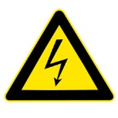
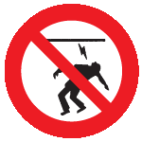
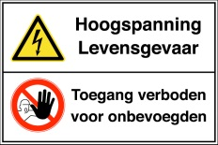

- TRAINING
- for working on electrical installations
Training must always conform with local laws - generally classified as:
    - laymen
    - sufficiently-trained/informed persons
    - skilled/authorised persons
- safety guard when working live - training in:
    - recognising risks during work
    - switching off the power supply
    - first aid techniques
- APPROVAL OF MATERIAL FOR WORKING ON ELECTRICITY
- visual inspection (condition of the material) before use
- periodic inspections
    - thorough inspection
    - conforming with local laws (frequency, body)

Kuwait Petroleum North West Europe

DOCUMENT TITLE: TSR - Electrical Installations

DOCUMENT NUMBER: KPNWE.WI.11.HSCO.083

REVIEW NUMBER: 0

EFFECTIVE DATE: 01 Dec 2017

NEXT REVIEW DATE: 01 Dec 2020
..

CONFIDENTIALITY:
The information contained in this document is confidential to Kuwait Petroleum International Ltd. Copyright © Kuwait Petroleum International Ltd. Copying of this document in any format is not permitted without written permission from the management of Kuwait Petroleum International Ltd.

This document is reviewed and approved according to the released online Document Approval Flow

Prepared by: | Operational Assistant | An Cornelis
Reviewed by: | Operational Assistant | An Cornelis
Approved by: | HSSE Manager | Gerardus Johannes Marinus Timmers

*Access rights: Generally Accessible

Reviews Summary

Review date | Review reference | Review details | Review version
2017-12-01 |  |  | 0

