- INTRODUCTION TO MOBILE ELEVATED PLATFORMS
Mobile elevated platforms are normally used for working at heights when it is not possible to build scaffolding, or when it is considered impractical (time, location, etc.). A risk analysis should identify this.

- EXPLANATION & RISKS
- Definition of a mobile elevated platform:  - a work platform that can be elevated  - using a hoisting mechanism  - in an arm or scissors construction  e.g. scissor lift, self-propelled elevated platform, elevated platforms on vehicles or trailers, telescopic, vertical mast elevated platform, push around, etc.  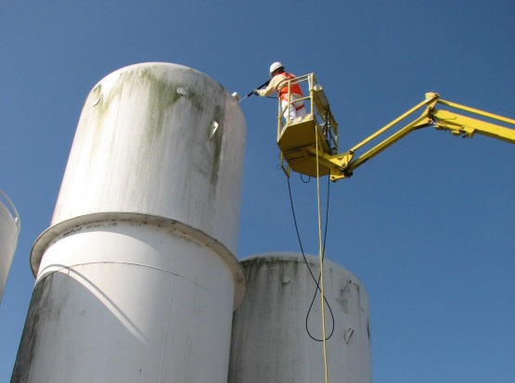 | Examples:  maintenance (snow, cleaning, lighting, ...) of canopies at petrol stations  work on monitoring cameras at a height  work on light fixtures at heights  installation of marketing items on canopies at gas stations  Installation/removal of signs on storage tanks  work on/cleaning of windows at office buildings  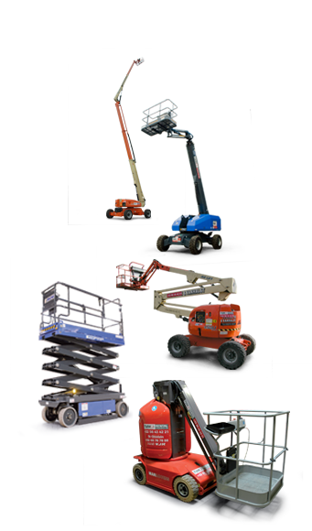
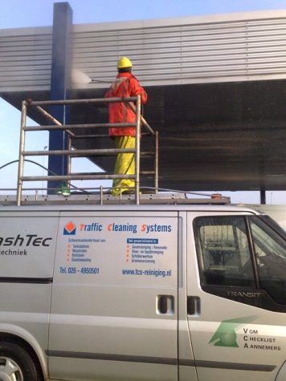

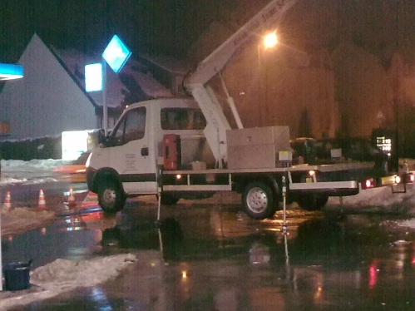

- The following risks exist (description of the risks + pictograms):
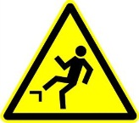
- persons falling from the elevated platform due to sudden movement of the platform or due to the operator leaving the basket (standing on the railing)
- pinching of persons (or body parts)
in the working platform or between the basket and other objects
- material falling to the ground
- toppling of the elevated platform (collision, sinking, wind or unbalanced)
- contact with live parts (e.g. power lines)
- not managing to get away in time in the event of an emergency

- SAFETY REQUIREMENTS
ALWAYS:
CHECK
- PERSONAL PROTECTIVE EQUIPMENT
- safety helmet with chin strap in open air
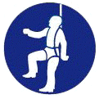
- safety shoes / boots
- harness belt, properly secured
- high visibility and weather resistant clothing
- life jacket when working on an elevated platform near water
- goggles, gloves and ear and eye protection, if required
- PREPARING TO WORK ON AN ELEVATED PLATFORM
- Assessment of the work (RI&E)
Duration, number of people on the elevated platform, whether material must be taken up, potential interference with other contractors on the site, etc.
- Terrain, exploration, assessment and measures for:
    - underground lines and areas - marking, etc.
    - overhead lines and obstructions - removal,
planning, etc.
    - overhead high-voltage line and/or telephone cables
    - carrying capacity and smoothness of the base - partitions
    - pits and trenches (and the edges thereof)
    - check the available space to move before positioning the elevated platform
    - demarcate the area and put up signs

- Weather conditions
    - It is not permitted to use an elevated platform under the following conditions:
      - wind speed> 6 Beaufort (> 50 km/h)
      - severe thunderstorms
    - ensure that operators/personnel on the work platform have suitable weatherproof (cold/wet) clothing available
    - take into account that cold could have an impact on the concentration of the operators (control/monitoring requirement)
- Emergency plan
    - accident scenarios for an elevated platform
    - staff instructions/training

ALWAYS:
CHECK
- REQUIREMENTS FOR WORKING ON AN ELEVATED PLATFORM
    - > 18 years old
    - the elevated platform must only be operated by qualified personnel
    - provide clear instructions for workers on the basket
    - good communication between workers in the basket and those on the ground
two-way radio needed when working higher than 25 meters
    - all workers must always be clearly visible, both on the basket and on the ground
- ELEVATED PLATFORM PROTECTIVE EQUIPMENT
- in explosion risk areas: spark arrestors on exhausts
- acoustic driving signal
- appropriate extinguishing equipment
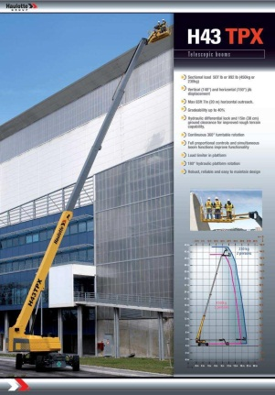
- overload protection and load limiter
- roll-over protection
- emergency lowering valve
- DOCUMENTS REQUIRED TO BE AVAILABLE
- CE certificate
- inspection report
- instruction manual for the machine in the local language (user)
- completed vehicle logbook (inspections, checks, maintenance)
- APPROVAL & INSPECTION OF ELEVATED PLATFORM
- with use, daily:
    - visual inspection: fluid levels, leaks, damage (tyres, ...)
    - operational inspection: ground handling, braking, emergency equipment, emergency stop, deadman's pedal, etc.
- valid periodical inspections
    - conform to local legal requirements (frequency/institution)
    - hoisting equipment with baskets and hoisting vehicles used as elevated platforms must also be inspected
ALWAYS: CHECK
- SAFETY PLATFORM USE SAFETY*
- safe driving
    - drive slowly
    - note low passages, pipes and cables
    - note pits, holes and bumps
    - maintain a sufficient distance from all obstacles
    - ensure that all other persons are a safe distance away
    - look in the driving direction when the elevated platform is being moved
    - driving up and down slopes: load must be directed towards the slope
- use the basket/working platform in a safe manner
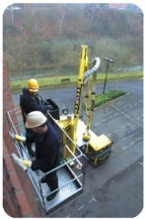
    - never overload
    - always keep in a horizontal position
    - Always keep the floor of the basket clean
    - workers must step on or off on ground level
    - only step on or off through the designated gate
    - check whether the personnel on the basket are making use of personal protective equipment used and if they are properly in place
    - secure tools and materials from falling
    - Avoid jerking movements of the basket, operation must be carefully and evenly
    - prevent electric cables, ropes or hoses getting tangled while hoisting or lowering the basket
- safe control
    - switch the elevated platform off when leaving the basket
    - always park in a safe place
    - stop immediately in the event of a defect or malfunction and notify the foreman/employer
*NOTE: for more information about baskets on hoisting equipment, see "Hoisting and Lifting"

KUWAIT PETROLEUM NORTH WEST EUROPE

DOCUMENT TITLE: TSR - Working at height - MEWP

DOCUMENT NUMBER: KPNWE.WI.11.HSCO.051

REVIEW NUMBER: 1

EFFECTIVE DATE: 06 Jul 2020

NEXT REVIEW DATE: 06 Jul 2023
..

CONFIDENTIALITY:
The information contained in this document is confidential to Kuwait Petroleum International Ltd. Copyright © Kuwait Petroleum International Ltd. Copying of this document in any format is not permitted without written permission from the management of Kuwait Petroleum International Ltd.

This document is reviewed and approved according to the released online Document Approval Flow

Prepared by: | Operational Assistant | An Cornelis
Reviewed by: | Operational Assistant | An Cornelis
Approved by: | QHSSE Manager | Gerardus Timmers

*Access rights: Generally Accessible

Reviews Summary

Review date | Review reference | Review details | Review version
01 Dec 2017 |  |  | 0
06 Jul 2020 | -- | minor changes | 1

