- INTRODUCTION TO WORKING ON ROOFS
It is very risky to work on roofs as a fall from a roof could cause serious injury or even death, more so than with any other forms of working at height. It is therefore important to take proper precautions.

- EXPLANATION & RISKS
- Definitions:  - working on sloping roofs = roofs with a slope of at least 15%  - working on flat roofs = roofs with a slope of up to 15%  - fragile roof = a roof that will collapse if a reasonably predictable weight is placed on it  + Fall height (defined in TSR - Working at height):  - > 2 metres ( > 2,5 m in NL) or  - < 2 meters (< 2,5 m in NL) and on protruding parts or above water or traffic  + near cliffs (site on steep slopes) | Examples:  Maintenance on/to:  canopies at filling stations  feeders  And on/to roofs of:  shops  technical areas  storage tanks at depots  warehouses and storage areas  loading racks at depots  offices  jetties at depots
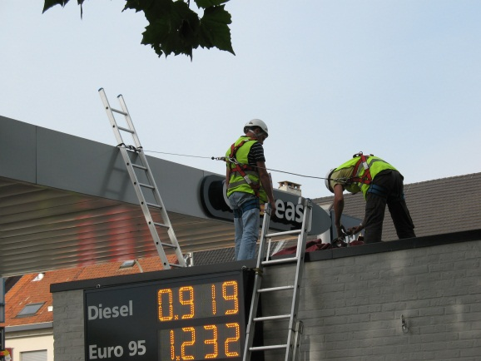
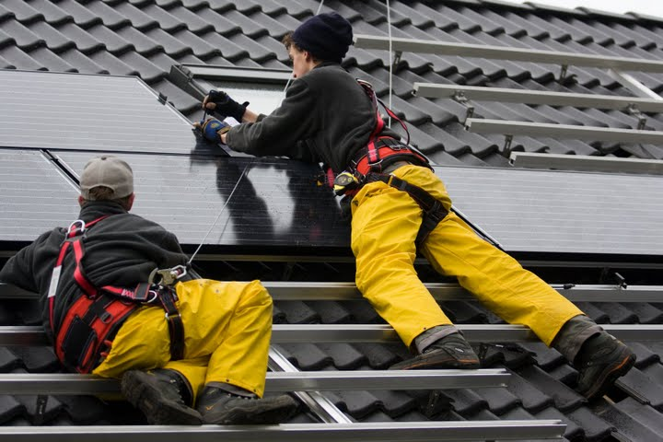

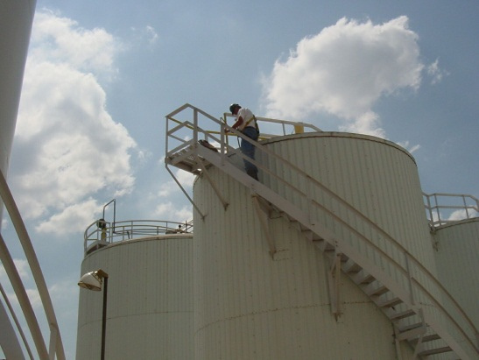

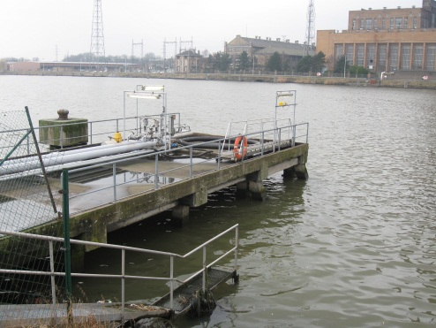

- The following risks are present:
- persons falling from roof edges, holes in roofs and through fragile roof covers and roof edge lighting
- falling material (accidentally or when it is thrown down)

- SAFETY REQUIREMENTS
ALWAYS:
CHECK
- PERSONAL PROTECTIVE EQUIPMENT
- safety shoes or boots
    - Anti-slip
    - with steel toes and steel soles
- protection against extreme heat and cold by means of adequate clothing and/or other protective equipment
- + depending on the nature of the work
    - fire retardant clothing
    - safety glasses
    - safety shoes
    - safety helmet
    - hearing protection
    - respiratory protection
    - knee protection
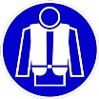
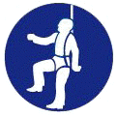
- + with unavoidable risk of falling
    - personal fall-arrest equipment (see below)
    - life jacket near water (e.g. jetty)
- PREPARATION
- visual inspection in accordance with the safety measures
- preliminary risk analysis and implementation plan including the following aspects
    - entrances, exits and emergency exits
    - structural integrity of the roof, including the cover and beams
    - distribution of weight on the roof
    - presence of existing fall prevention and protection measures
    - need for additional fall prevention and protection
    - asbestos register (if applicable)
    - other factors that could affect the safety of workers
    - staff training
    - emergency plan
- check if all safety measures have been taken and if the appropriate signage is in place

ALWAYS:
CHECK
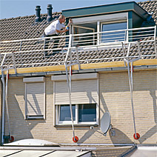
- WORKING ON SLOPING ROOFS
- roof edge safety - in order of preference:
    - permanent fencing and railings
with the same requirements as scaffolds,
see TSR – Scaffolding
    - safety nets, scaffold or platform
see TSR – Scaffolding
    - individual fall protection equipment (PPE)
- safety on a sloping roof
    - close off openings and fragile parts
    - roof ladders for moving on a sloping roof
(not directly on the tiles)
    - work platforms around chimneys (if work is required there)
- WORKING ON FLAT ROOFS
- working > 4 m from the edge of the roof
    - = secure zone
    - 4 m distance marker (e.g. paint) on the roof
    - no other protection is required within the marked area
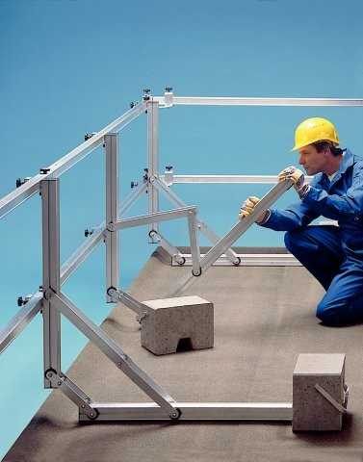
- working between 2 and 4 m from the edge of the roof
    - is only a secure zone of:
      - there is a physical barrier in place
      - 2 metres from the edge of the roof
      - parallel to the edge of the roof
(e.g. posts with a chain)
OR
    - see edge of roof safety for sloping roofs
- working at < 2 meters from the edge of the roof
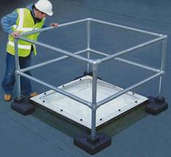
    - see edge of roof safety for sloping roofs
- safety on a flat roof
    - close off openings and fragile parts

ALWAYS:
CHECK
- WORKING ON FRAGILE AND DIFFICULT ROOFS
E.g.: steep roofs, small roofs (limited m³), ​​corrugated roofs of warehouses, old roofs, feeders (plastic), aerial storage tank roofs (see further) ...
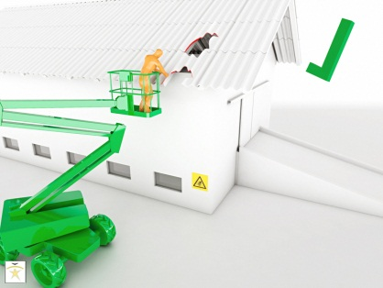
- consider alternatives (risk analysis), such as
    - perform the work on the ground - if at all possible/feasible
    - use an elevated platform if it is possible to work from there without stepping onto the roof
(see TSR – MEWP)
    - use a scaffolding to work from there without stepping onto the roof (see TSR – Scaffolding)
IF IT IS NECESSARY TO STEP ONTO THE ROOF:
- screen off the fragile sections
    - edge protection on fragile points
    - complete roof edge protection if the entire roof is fragile
- prevent unauthorised access
    - by blocking access to roof ladders
    - and put appropriate signs in place
- work from work platforms
    - with top and middle railings and edge protection
    - of sufficient size
    - supported by the non-fragile parts
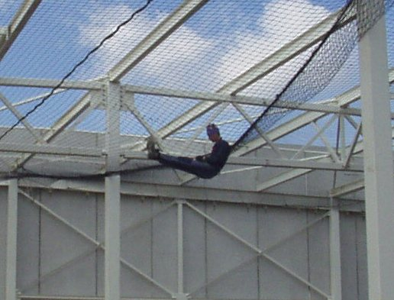
IF WORK PLATFORMS ARE NOT AN OPTION:
- hang safety nets under the roof or
- use individual fall protection equipment
- MATERIAL FOR WORKING ON ROOFS & WASTE
- always keep the roof tidy and clean
- pay extra attention to the placement of material on fragile roofs
- Use chutes or containers for taking waste down
- do not leave any material behind on the roof after finishing work
    - especially during weekends and on holidays
    - if material remains, ensure that the material is secured so it will not be blown off the roof during stormy weather (e.g. advertising)
    - always remove gas bottles and/or other dangerous goods

ALWAYS
CHECK
- TRAINING
- inform workers of the risks involved with working on roofs
- provide all training needed regarding the fall prevention and/or safety
    - scaffolding: see TSR – Scaffolding
also for the construction of edge of roof scaffolding/protection
    - elevated platforms: (see TSR – MEWP)
    - ladders: see TSR – Ladders
- EVACUATION & EMERGENCY
- provide an emergency plan with a scenario for accidents on the roof
- ensure that adequate escape routes are available on the roof
    - if necessary through additional scaffolding/stairs towers
(see TSR – Scaffolding)
- ADDITIONAL PRECAUTIONS
- with "hot work" on the roof, see TSR - Hot Work
- when working on electrical installations, see TSR - Electrical Installations
- for hoisting and lifting, see TSR - Hoisting/Lifting

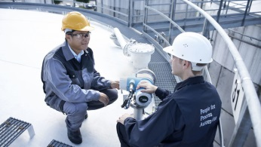
TANK ROOF ENTRY & WORKS
E.g.: gauging, sampling, visual inspections,
working on sprinklers and annular water piping,
calibration of measuring equipment …
CHECK
- PRINCIPAL = DO NOT ENTER
- Consider alternatives (risk analysis), such as
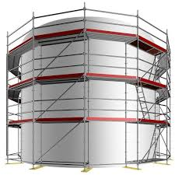
    - perform the work on the ground - if at all possible/feasible
    - use an elevated platform if it is possible to work from there (see TSR – MEWP)
    - use a scaffolding (see TSR – Scaffolding)
- Refer also to the requirements for fragile and difficult roofs in point 5.
- IF THE TANK ROOF ENTRY IS NECESSARY/INEVITABLE:
- Fall protection
    - Always mandatory when working on the edge of the roofs or near the access stairs and bridge platforms
    - Not mandatory for inspections (e.g. visual inspections and calibrations) and sampling, provided there is a proper edge protection and the risk of tripping is excluded
- Additional task risk assessment (TRA) with attention for
    - Nature of the works and work method
    - existing control measures (stairs, guardrails, antiskid paths …)
    - additional control measures (work method, collective and personal protection, emergency plan …)
- Start work meeting and work permit
    - identification of weather conditions (also see point 11)
    - visual check of the condition of:
      - stair(s) towards the tank roof, from the ground
      - roof surface(s), from the stairs if safe
      - bridge platform(s) between tanks using the safest method
    - check the presence and the condition of the collective and personal protective equipment
    - with all involved employees, go through the work method, the risks, the control and emergency measures (TRA)
- ONCE ON THE TANK ROOF, THE FOLLOWING IS IMPORTANT
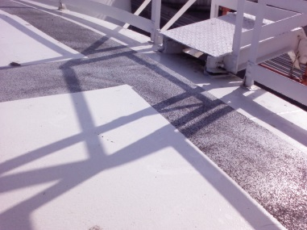
- When moving/walking, stay on the
antiskid walkways
- Avoid crossing other people, also
on the antiskid walkways
- When doing inspections or sampling, working
alone is allowed when additional measures
are taken

KUWAIT PETROLEUM NORTH WEST EUROPE

DOCUMENT TITLE: TSR - Working at height - Roof work

DOCUMENT NUMBER: KPNWE.WI.11.HSCO.059

REVIEW NUMBER: 1

EFFECTIVE DATE: 06 Jul 2020

NEXT REVIEW DATE: 06 Jul 2023
..

CONFIDENTIALITY:
The information contained in this document is confidential to Kuwait Petroleum International Ltd. Copyright © Kuwait Petroleum International Ltd. Copying of this document in any format is not permitted without written permission from the management of Kuwait Petroleum International Ltd.

This document is reviewed and approved according to the released online Document Approval Flow

Prepared by: | Operational Assistant | An Cornelis
Reviewed by: | Operational Assistant | An Cornelis
Approved by: | QHSSE Manager | Gerardus Timmers

*Access rights: Generally Accessible

Reviews Summary

Review date | Review reference | Review details | Review version
01 Dec 2017 |  |  | 0
06 Jul 2020 | -- | minor changes | 1

