- INTRODUCTION TO CONFINED SPACES
A confined space is a hazardous working environments as they are often damp, dark and poorly ventilated. The risks encountered here can also be encountered elsewhere, but in confined spaces is much harder to do something about it. It is therefore important to always be aware of the risks and to closely observe safety measures.

- EXPLANATION & RISKS
- Confined spaces are spaces - also above ground:  - that are not readily accessible  - that are not easy to exit quickly  - with poor ventilation  - with no or poor lighting  - with little room to move  - where a hazardous atmosphere is present  - which are not intended for a long stay  - with pipes and cables in unexpected places  - that are small, damp and inconvenient | Examples:  tank  measuring well  excavated wells, deep trenches  crawl space  oil separator  passages,  elevator shaft  sewers, drains
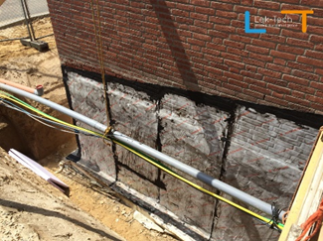
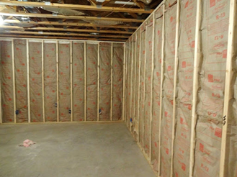

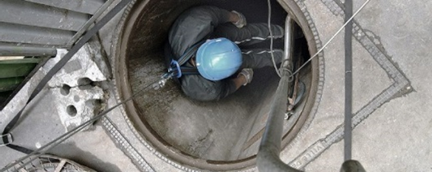

- There are many risks involved with confined spaces: (pictograms and additions)
- fire and explosion caused by vapours/gases in the room itself or that may be created due to the nature of the work (fire and sparks)
- suffocation due to oxygen deficiency
- poisoning caused by hazardous substances from the work, piping, welding, ...
- electrocution due to sweating (wet skin) because of poor ventilation or conductive materials in the space
- pinching due to lack of space to move, especially if there are moving parts
- falling and slipping through products present, moisture, moss and other formations

- SAFETY REQUIREMENTS
ALWAYS
CHECK
- Standard PERSONAL PROTECTIVE EQUIPMENT
- protective clothing
- safety glasses
- safety gloves
- safety shoes or boots
- safety helmet
- fall protection/rescue equipment if necessary
- SAFETY GUARD
ALWAYS keep 1 person outside as a safety guard - tasks:
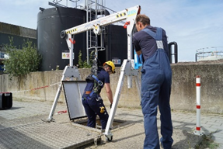
    - communication with persons in the confined space;
    - monitoring of ventilation device;
    - call in emergency services in the event of an accident
and provide assistance to the person in the confined space.

- WORKPLACE SIGNALLING/SIGNPOSTING
e.g. signal with fence of strong grids (concrete grid) on the openings, signalling by safety ribbon …
- open wells
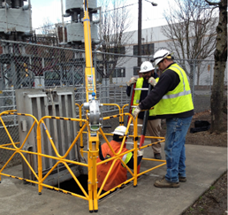
- horizontal manholes
- open ventilation holes
- EVACUATE/SAVE= PEOPLE FROM CONFINED SPACES
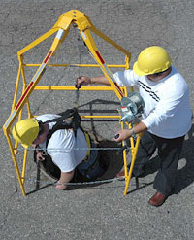
Objective: it must always be possible to remove the
person from the confined space without any
difficulty and without the safety guard having
to enter the confined space
Options: - lifeline
- fall harness
- with tripod hoist (with motor)
- ….

WHEN APPLICABLE
CHECK
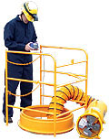
- VENTILATION and AERATION for
- removal of dust from the space itself ventilation in general
- dust caused by work local removal
- or both if both are available
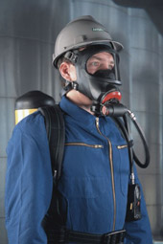
- INDEPENDENT RESPIRATORY PROTECTION.
- with concentration of hazardous gases > limiting value
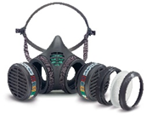
- as oxygen concentration < 19%
- MEASURING OF OXYGEN, TOXIC AND HAZARDOUS SUBSTANCES
e.g. with welding, cutting, painting, varnishing and solvents
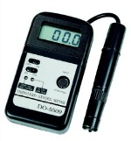
- before entering if
    - oxygen - minimum 19%
    - vapour or gas concentrate - < 10% of the LEL
    - hazardous substances - below the limit value
- continuously if these risks remain
See also TSR / Measurements of dangerous goods
ALWAYS:
CHECK
- FUEL STORAGE TANK ENTRY
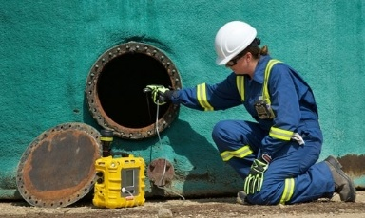
Continuous measurement is required when:
    - one enters the tank without
respiratory protection or
    - there is no permanent ventilation
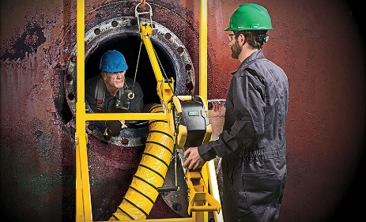
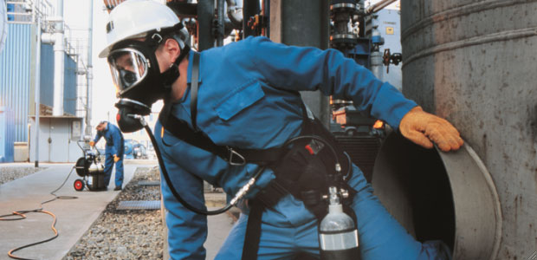

WHEN APPLICABLE
CHECK
- FLAMMABLE SUBSTANCES in a confined space
e.g. with welding and cutting
- remove or cover all combustibles
- put spark arrestors in place
- FIRE EXTINGUISHING EQUIPMENT
Always:
- Choice of extinguishing media in function of the task and its risks
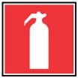
- to be put outside and near the entrance to the confined space
- to provide in case of flammable materials in confined spaces
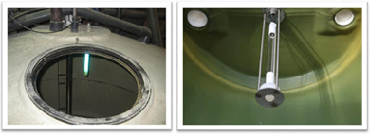
- LIGHTING in the confined space
- always required when the exit is not visible
- always needed when slipping or falling must be avoided
- explosion proof lighting in explosion risk areas
- ELECTRIC APPLIANCES
- in explosive atmosphere explosion-proof appliances and lighting
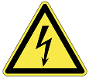
- no transformers in the confined space
- make use of devices on secure voltage
- electrical installations in the confined space must be turned off
TIP: special attention is required for the isolation - and especially against damage - of cables, devices and grounding of the conductive walls of the enclosure
- HEARING PROTECTION
- with noisy work and/or
- when the nature of the confined space requires it

KUWAIT PETROLEUM NORTH WEST EUROPE

DOCUMENT TITLE: TSR - Confined spaces

DOCUMENT NUMBER: KPNWE.WI.11.HSCO.063

REVIEW NUMBER: 1

EFFECTIVE DATE: 06 Jul 2020

NEXT REVIEW DATE: 06 Jul 2023
..

CONFIDENTIALITY:
The information contained in this document is confidential to Kuwait Petroleum International Ltd. Copyright © Kuwait Petroleum International Ltd. Copying of this document in any format is not permitted without written permission from the management of Kuwait Petroleum International Ltd.

This document is reviewed and approved according to the released online Document Approval Flow

Prepared by: | Operational Assistant | An Cornelis
Reviewed by: | Operational Assistant | An Cornelis
Approved by: | QHSSE Manager | Gerardus Timmers

*Access rights: Generally Accessible

Reviews Summary

Review date | Review reference | Review details | Review version
01 Dec 2017 |  |  | 0
06 Jul 2020 | -- | minor changes | 1

