- INTRODUCTION TO EXCAVATIONS
Studies have shown that excavation involves some of the most hazardous work in the building industry. Injuries caused by incidents involving excavation are predominantly very serious and even fatal. It is extremely important to closely follow the different safety aspects when involved with this type of activity.

- EXPLANATION & RISKS
- What is included under excavation:  - excavation and moving of soil  - soil drillng  - placing filters/drains  for groundwater remediation  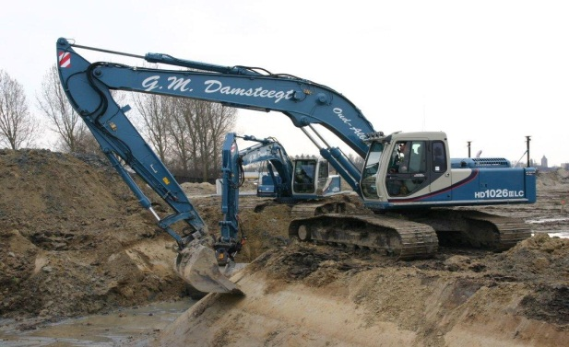 | Examples:  excavations for placing tanks  installation of pipelines  installation of hydrocarbon separators (KWS, OBAS)  soil surveys  ground and or groundwater decontamination  installation of tanks at filling stations or depots
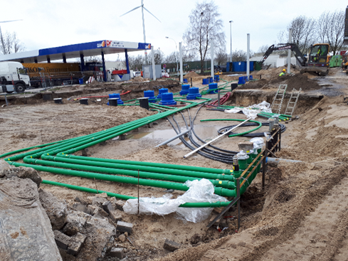

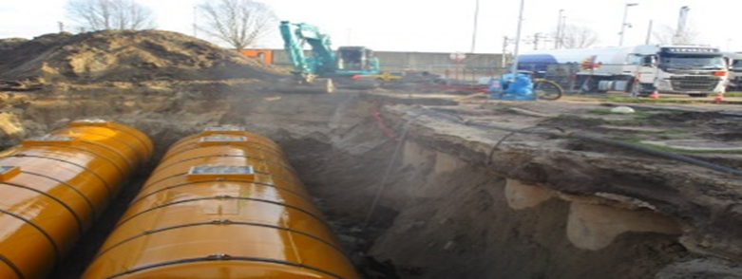

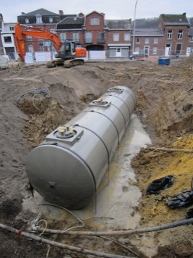

- There are many risks involved with excavation activities:
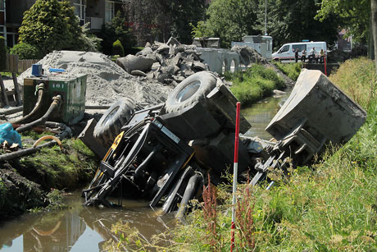
- sinking and collapse of machines
- collision
- entrapment of workers
- collapse of trenches and wells (confined space)
- hitting and electrocution by cables and pipelines
- hazardous substances due to soil contamination
- contact with underground pipes and spaces

- SAFETY REQUIREMENTS
ALWAYS: CHECK
- PERSONAL PROTECTIVE EQUIPMENT
- safety vest/fluorescent vest
- safety shoes or boots
- safety helmet
- hearing protection above 80 dB(A)
- respiratory protection with soil contamination (> 10 ppm)
- safety goggles and gloves for
refilling dangerous goods like antifreeze, brake fluid and fuel
- NO OPEN, HANGING CLOTHING ITEMS
- DRIVERS: KEEP HANDS AND SHOES CLEAN
- PREPARATION FOR EXCAVATION WORK
- Explore the site (location of passageways, pits, obstacles, ...)
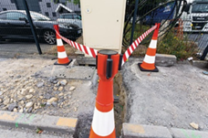
- Soil surveys (mesures for contaminated soil)
- Terrain stability studies
- Location of cables and pipes must be known and marked
(additional test trenches if unsure)
- Stake out the work terrain
- Seal/close public utilities
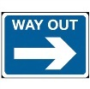
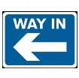
- TRAFFIC PLAN FOR THE SITE (also for other vehicles)
- signs identifying ENTRANCE and EXIT
- indication of the way to follow between the ENTRANCE and EXIT
(if necessary)
- maximum speed indication
- other internal traffic and HSSE rules, depending on the situation
CONSTRUCTION EQUIPMENT
(excavator, dump truck, tumbrel, shovel, ...) CHECK
- DAILY INSPECTION of/on
- leaks
- defective or missing parts
- tyre pressure
- condition of the tyres and tracks
- level of engine oil, brake fluid, hydraulic oil and coolant
- operation all functions
- operation of lights, horn, belts, roll back protection, ...
- cleanliness of handles, steps, cab and control levers
- WORKING SAFELY WITH CONSTRUCTION EQUIPMENT
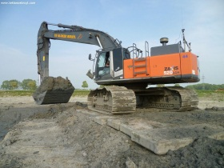
- during excavation:
    - always keep the machine in a horizontal position
    - keep a safe distance from trenches and pits
    - (Dragline) partitions under machine with soft ground
    - NEVER swing the excavation arm over the cabs of other machines
- for the machines, in general, prevent:
    - falling and slipping
    - major shocks
    - the drive wheels from continuously turning
    - driving on public roads as far as possible
(the machine must meet the requirements for road use)
- lifting with earthmoving machinery: must meet the demands of lifting equipment
- always drive slowly
- do not use your cell phone (mobile) when driving machines
- keep away from holes, obstacles and markers
- only transport passengers if appropriate seats are in place
- ensure a good view, assign a safety guard or use a camera
- make sure that the machine is clearly visible (light)
PARKING, MAINTENANCE AND INSPECTION OF THE MACHINES
CHECK
- SAFE PARKING OF THE MACHINE
- set the machine horizontally as far as possible
- completely switch the machine and electrical equipment off
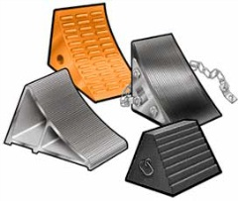
- transmission neutral, handbrake up, key out of the ignition
- remove pressure from the hydraulic system
- secure the machine against running away
- close the filler plugs (including those of the mobile refuelling tanks)
- MAINTENANCE AND INSPECTION OF THE MACHINE
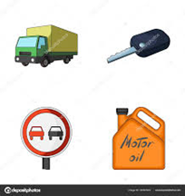
- periodic inspections and maintenance
- inspection at least once a year (with indication of validity)
- for hoisting equipment see TSR Hoisting
GUIDELINES & STAFF SAFETY
CHECK
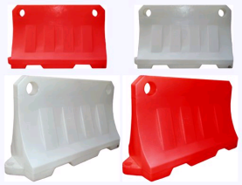
- SECURE THE PERIMETER OF LARGE EXCAVATION SITES
- DO NOT use red-white tape
    - Does not prevents falls
    - easily blown away by the wind
    - pollutes the area
- Choose a more solid edge protection that can prevent falls
(heras, plastic water-filled barriers, shelf fencing, ...)
- POINTS OF ATTENTION FOR WORKERS IN THE VICINITY
- always wear all PPE (personal protective equipment), make sure you are visible and keep eye contact
- never approach the machines from behind
- do not ride along unless an extra seat is available
- do not walk in the turning radius, blind spots or under the load of a machine
- respect the traffic plan and do not cross routes and excavation jobs unnecessarily

KUWAIT PETROLEUM NORTH WEST EUROPE

DOCUMENT TITLE: TSR - Excavations

DOCUMENT NUMBER: KPNWE.WI.11.HSCO.067

REVIEW NUMBER: 1

EFFECTIVE DATE: 06 Jul 2020

NEXT REVIEW DATE: 06 Jul 2023
..

CONFIDENTIALITY:
The information contained in this document is confidential to Kuwait Petroleum International Ltd. Copyright © Kuwait Petroleum International Ltd. Copying of this document in any format is not permitted without written permission from the management of Kuwait Petroleum International Ltd.

This document is reviewed and approved according to the released online Document Approval Flow

Prepared by: | Operational Assistant | An Cornelis
Reviewed by: | Operational Assistant | An Cornelis
Approved by: | QHSSE Manager | Gerardus Timmers

*Access rights: Generally Accessible

Reviews Summary

Review date | Review reference | Review details | Review version
01 Dec 2017 |  |  | 0
06 Jul 2020 | -- | minor changes | 1

